AGM Weekend 2026
The weekend programme this year will run from Friday 5th June to Sunday 7th June. The Society AGM will be held once again at Mackintosh Queen’s Cross at 10.30am.
We advise early booking due to limited numbers for some parts of the programme. The programme is for members only, but as ever we welcome new members who can join in order to participate in the programme.
AGM Weekend Programme
Friday 5th June
3pm - Members tour of Glasgow City Chambers, 20 spaces available
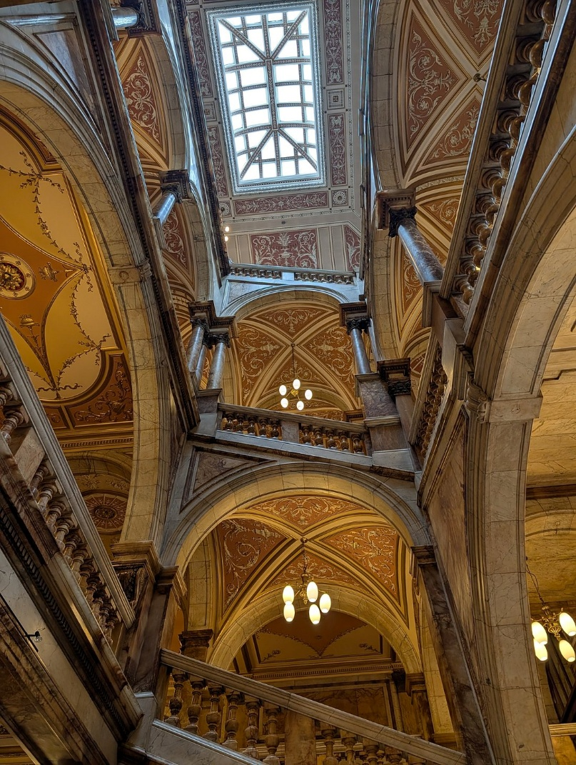
Meeting outside the main door of the City Chambers located on the east side of George Square in Glasgow. The tour lasts 45 minutes to an hour depending on questions from the group.
Designed by Paisley architect William Young, construction on the City Chambers commenced in 1882 with the building inaugurated by Queen Victoria in 1888. The Beaux-Arts style exterior holds a variety of richly decorated public spaces including a grand entrance hall and atrium with marble staircase, an ornate banqueting hall, and the council chamber itself. This opulent gem with its eclectic classical styling demonstrated Glasgow’s wealth and trading power during Mackintosh’s lifetime. It serves as a counterpoint to his style, highlighting just how revolutionary Mackintosh really was. We advise early booking as only 20 places are available.
Please note that George Square is closed for renovation so car travel and parking options are restricted. Queen Street Station and Buchanan Street Subway are both within easy walking distance.
Saturday 7th June
10.00am Teas and coffee served before the AGM at Mackintosh Queen’s Cross.
10.30am AGM commences, this can also be viewed on Zoom
12.45pm Buffet lunch served in the church
2.00pm – Talk by Alison Brown, Mackintosh and the Glasgow Style, Highlights of Glasgow’s Civic Collection
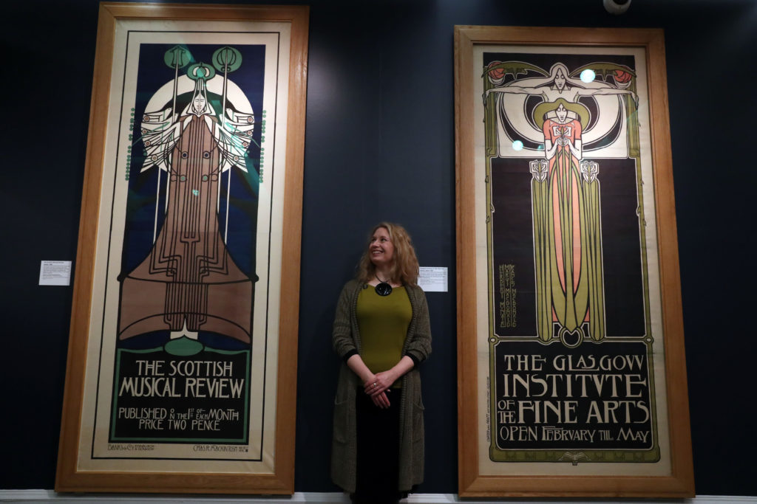A Virtual behind-the-scenes tour featuring some of the many highlights of the collection as well as lesser-known treasures of the Glasgow Style, giving insight into details, techniques, collecting history, owners and the makers themselves.
Alison, a former Vice Chair of the Society, is the Curator of European Decorative Art and Design at Glasgow Museums. Her long-time focus has been on CRM and the Glasgow Style with many publications to her name. Alison was the curator of Charles Rennie Mackintosh –Making the Glasgow Style, at Kelvingrove which subsequently toured to Liverpool and four US venues as part of the 2018 celebrations of the 150th anniversary of CRM’s birth.
At the end of the talk Alison will be happy to answer questions and is eager to hear your ideas for future displays, themes, makers and so on that would interest you in future museum displays.

3.15pm – Short Talk and Tour of This Home, This Voice
We’re pleased to participate in the Glasgow International (GI) art festival this year. GI is free and open to all and presents an array of artists’ projects across Glasgow, by international artists and those based locally. The festival amplifies the city’s identity as a vibrant centre for artistic production, presentation and cultural organising; and as a place with deep connections to international cultural and social concerns.
We’re delighted that Mackintosh Queen’s Cross has been included as a venue this year, particularly as the work exhibited highlights the important work of Maryhill Integration Network (MIN).
For This Home, This Voice, Maryhill Integration Network (MIN) and artists Helen McCrorie and Annabel Wright have collaborated on a behind-the-scenes portrait of MIN’s vital work, developing artistic responses to the experience of community-building in Glasgow.
MIN works alongside refugees, migrants, and people seeking asylum, with a focus on campaigning, wellbeing, and creativity. Helen McCrorie and Annabel Wright share a passion for documenting community groups and social activities and celebrating grassroots activism. The project has evolved through mutual learning and exchange.
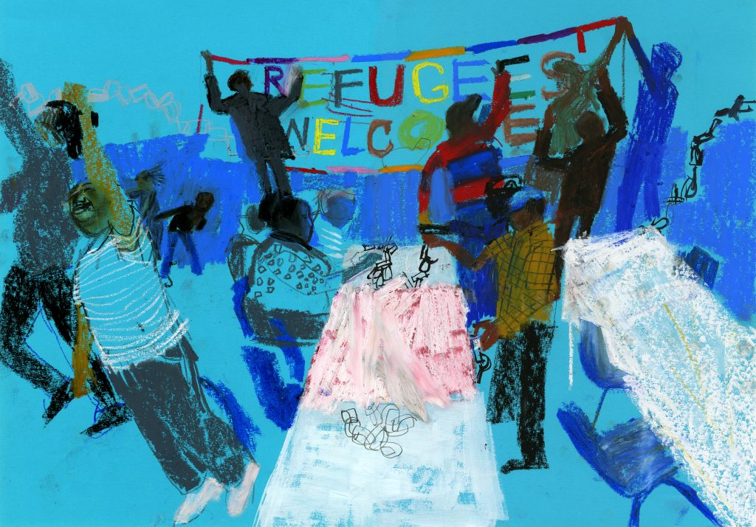
In the year of MIN’s 25th anniversary, the resulting exhibition celebrates and reflects on daily acts of care and solidarity, through an evocative collage of drawings, sound recordings, 16mm film, and animation.
Helen McCrorie is an artist and filmmaker based in Perthshire. Her practice cobmines documentary filmmaking methods and collaborative workshops in sound and mixed media. Helen’s work has been shown extensively at international film festivals, art festivals and galleries such as Collective in Edinburgh.
Annabel Wright is a Glasgow-based illustrator whose love of drawing and visual recording is at the heart of her practice. People are the focus of Annabel’s work and she often uses sketches from life and draws and redraws her subjects to understand their visual potential and best express human emotions. Alongside her community projects Annabe’s work has featured on everything from postage stamps to pyjamas and clients include the Financial Times, Penguin Books and The New Yorker. Her record sleeves include The Pastels, Teenage Fanclub and Sleater-Kinney.
Sunday 7th June
2.30pm – Glasgow Phoenix Choir Concert, Mackintosh: A Birthday Celebration
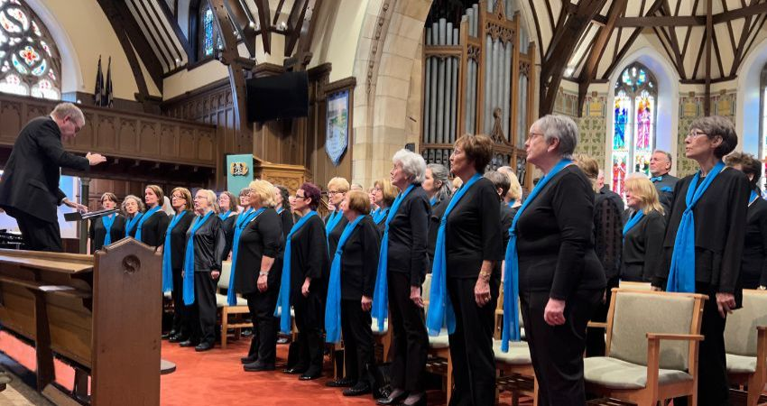
The choir is delighted to make a return to Mackintosh Queen’s Cross to celebrate the Birthday of Charles Rennie Mackintosh (7th June 1868). The Glasgow Phoenix Choir is now performing its 75th season of choral excellence. Their conductor, Cameron Murdoch joined them in 1987 as Accompanist and Depute Conductor, taking over as conductor in 2019. Cameron is also Organist and Choir Master of St. John’s Renfield Church in Glasgow’s West End and is accompanist to the excellent Glasgow CREATE Choirs. Many of the pieces in the current Phoenix repertoire were arranged by Cameron.
The Glasgow Phoenix Choir performs many concerts every year, the majority of which raise money for charity and each involves a range of music from choral standards to new music and, in addition, features many delightful solo performances from choir members.
Matthew McIlree, their regular accompanist, will perform at the concert. He has been a multiple prize winner at both the Glasgow and Inverclyde music festivals, including twice winning the Glasgow Society of Organists’ Trophy at the Glasgow open organ class; and three times winning the top piano award, as well the 2016 overall prize, in Inverclyde. He is now undertaking PhD studies and in his ‘spare time’ works as a freelance wedding musician and accompanist. Matthew can also be heard playing the organ as part of the daily recital programme at Kelvingrove Art Gallery.
With limited tickets available we advise early booking.
The following ticket types are available online via the Members section of the website, or by clicking on the link in the Newsletter:
- City Chambers Tour - Free
- AGM only – Free
- AGM plus lunch and talks - £25
- AGM plus lunch, talks and concert - £30
- Concert only - £5 (usually £10)

