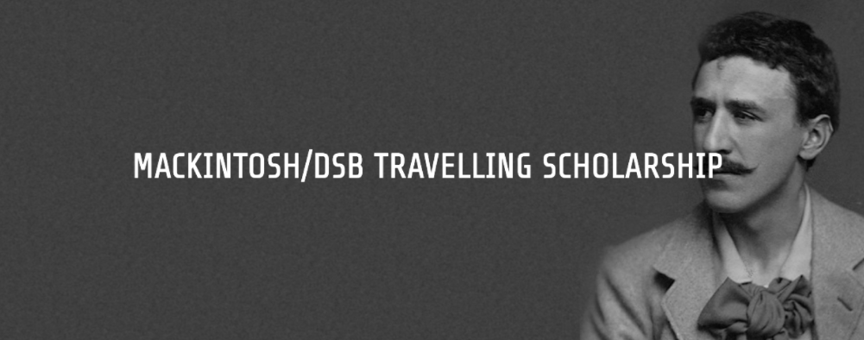

Mackintosh/DSB Travelling Scholarship 2022

Application Form

Please refer to the information on the scholarship contained on the Charles Rennie Mackintosh Society website: https://www.crmsociety.com/news/mackintosh-travelling-scholarship/

For any enquiries regarding the application process, please contact Alan Hooper MSA UG Programme Leader (a.hooper@gsa.ac.uk).

The application submission consists:

-completed application form (see below)

-an A1 poster presentation of your research proposal with text (max 500 words) and appropriate supporting high-resolution images (pdf file)

Completed applications including the application form must be submitted via a web-based file transfer service (such as WeTransfer) to stuart@crmsociety.com by the deadline of 12noon (GMT) on Friday 22nd April 2022.

Before submitting, please check that your form is signed by MSA Head of School: Sally Stewart (s.stewart@gsa.ac.uk).

Section 1: Personal Details
First Name: | Surname:
Title (e.g., Mr, Ms, etc): | Date of birth:
Address:
GSA Email: | Telephone:
Current Programme/Stage within MSA:
(Ie B’Arch (Hons) Stage 4)

Section 2: Description of your project
Please provide a summary of your project in no more than 200 words. Please state the title of your proposed travel project, the period in which you would travel, where you intend to travel, and the aims. The text must be typed in the box below.

Section 3: Anticipated costs of project
Category | Amount | Description
Travel | £
Accommodation | £
Other expenses | £
TOTAL | £

Student Name: | Signature: | Date:
Head of School | Signature: | Date:

